Pathology Requesting Dashboard A+E Report October 2016

- Overall Requesting Costs
(Actual calculated costs from finance will differ and this should only be used as a guide for the purpose of this report)
£21929.46 Estimated spend on biochemistry/haematology/Immunology tests by HoEFT A+E for October 2016. (Includes Good Hope and Solihull)
This represents a 3% increase on September (£21217) and an 11% increase on August (£19794).
During October we have records for 34704 tests being charged to A+E on 4456 distinct patients which is an 8% increase in testing and a 6% increase in patients from September, 32162 tests and 4187 patients tested.
The Bubble chart below displays the relative cost of each test, as you can see the most money is being spent on Troponin testing which accounts for 31% of total costs, but only represents 3% of total testing as it is significantly more expensive than other tests.
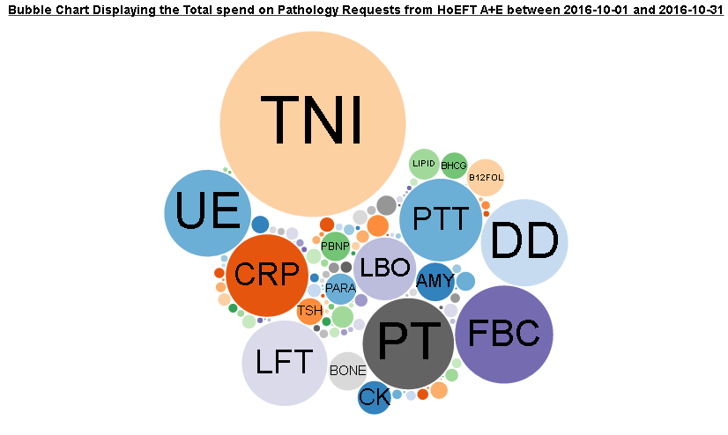
http://ebh24751:8000/graphs/costs_bubble/?start=2016-10-01&end=2016-10-31&view=spend&highlight=none
- Repeats
£124 was spend on A+E requests repeated within 180 minutes within A+E during October excluding troponin (£393 including) which is up from Septembers £92 (£369 including Troponin).
This only represents samples charged to A+E pathology twice, the actual figures for retesting between departments is much higher.
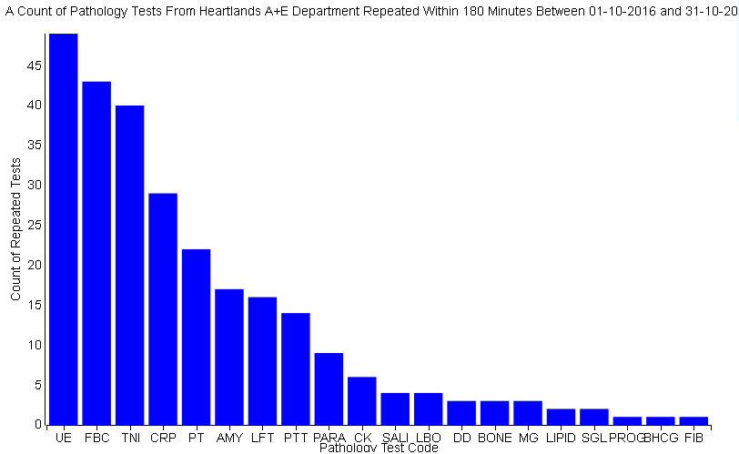
http://ebh24751:8000/graphs/repeats/?start=2016-10-01&end=2016-10-31&mins=180
- Add-on tests
£999 extra was charged to A+E in October for tests added on more than 4 hours after the initial test. This is significantly more than the £702 extra added in September.
This is not an exact representation of the additional cost being place on A+E by add-on test as 4 hour difference is only an estimate of the time taken to leave A+E. When reduced to a 1 hour window the cost rises to £1616 but is likely to contain some tests being added from within the department.
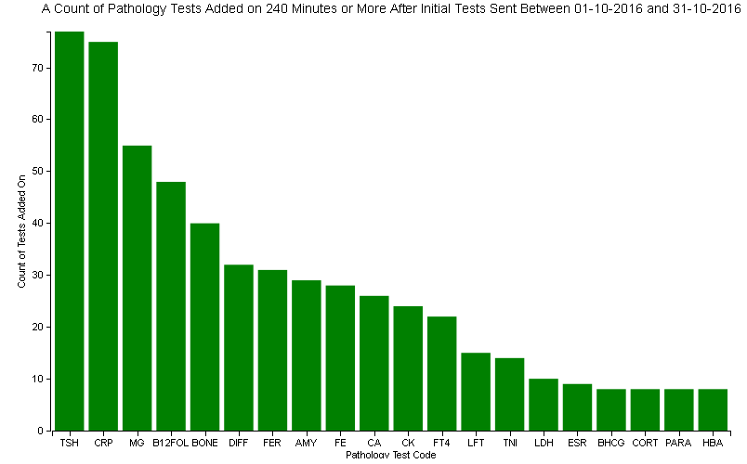
http://ebh24751:8000/graphs/addons/?start=2016-10-01&end=2016-10-31&mins=240
Investigating this in further detail we can see that the biggest cost comes from B12 and Folate addons (£142).
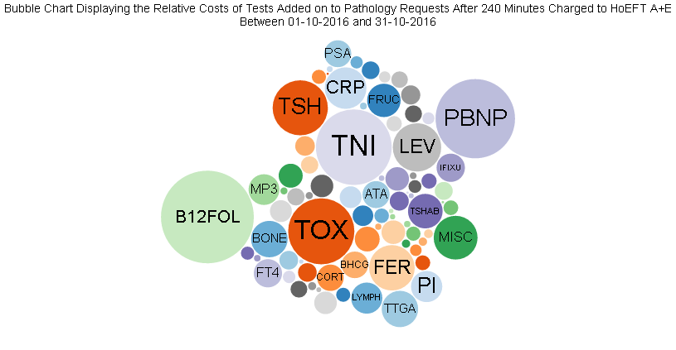
http://ebh24751:8000/graphs/addons/cost/?start=2016-10-01&end=2016-10-31&mins=240
- ICE Requesting
70% of A+E pathology requests made during October 2016 were made electronically through ICE requesting, an increase on the 62% seen in September.
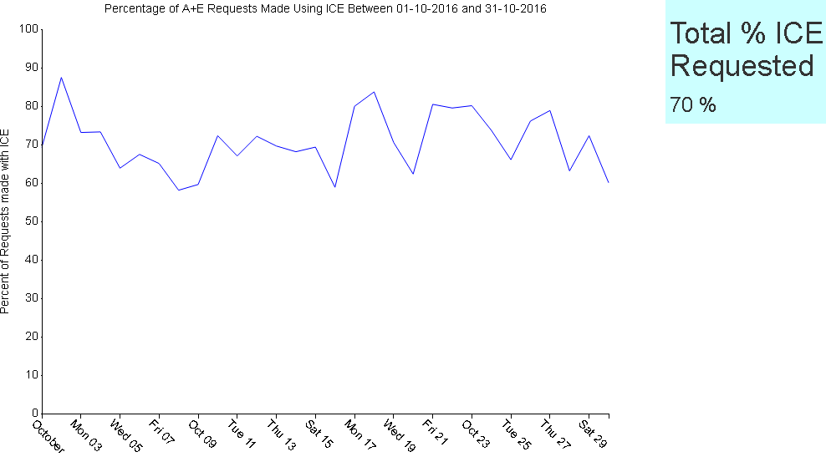
http://ebh24751:8000/graphs/ice_n/?start=2016-10-01&end=2016-10-31
We can see from the graph that the daily percentages generally fluctuate between 60% and 90%, which is not much different to September except for an isolated weekend when ICE requesting was unavailable.
- Investigating Bundles
Within ICE requesting for A+E there are several pre-defined testing bundles designed to be used for specific patient presentations. We will investigate the data we have with respect to these bundles to work out if anyone is using them.
We will investigate 3 ICE bundles, acute coronary syndrome (ACS), stroke and first fit.
To do this we will need to define symptomatic patient groups by keyword searching the “presenting complaint”, “clinical details” and “diagnosis description” fields within the database. We appreciate that these “symptomatic groups” may not be perfectly defined and would welcome input to improve our keyword selection.
ACS – “palpitation”, “chest pain”, “ACS”, “acute coronary”
Stroke- “CVA”, “TIA”, “Stroke”
First Fit – “fit”, “seizure”, “convulsions”
These symptomatic groups only includes patients with pathology requests from any A+E consultant on the day of their A+E attendance.
Bundles are counted as ordered if all sets are requested on the same specimen, this will include individually selected test sets that also match the bundle as there is no way to distinguish them. This will also exclude bundles which have had 1 or more tests removed.

Acute Coronary Syndrome (ACS)
This bundle suggests UE, FBC, TNI, SGL, CK and LIPID should be tested on all patients displaying symptoms of ACS. This bundle has been requested up to 1057 times over the last 4 months however we have identified 2428 patients with potential ACS symptoms.
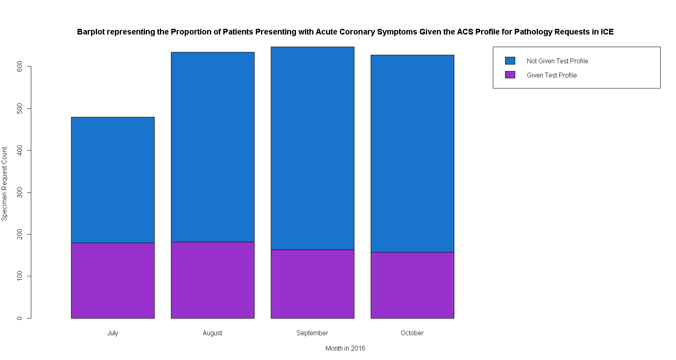
The above graphs shows the spread of these 1057 bundle requests with respect to the “syptomatic patient group” defined by our keyword search. The levels of symptomatic patients getting the full bundle seems pretty consistant over the months with a total percentage of 28.7%.
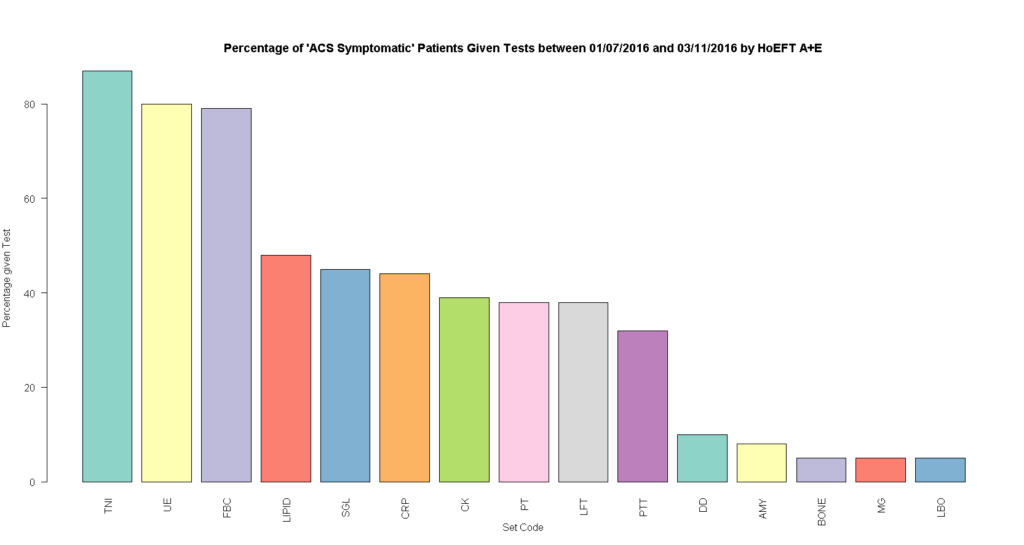
The above graph shows the percentage requesting levels of pathology tests on ‘ACS Symptomatic’ patients. The TNI, FBC and UE tests are generally being requested on all patients however the rest of the bundle, LIPID, SGL and CK seem to be considered less significant by clinicains in these cases.
Stroke
This profile suggests UE, FBC, PT, PTT, SGL, LIPID and ESR should be tested on all patients presenting with stroke symptoms. The profile was requested 323 times from A+E over the last 4 months but only 256 times on patient defined as “stroke symptomatic”. In total there were 695 “stroke symptomatic” patients from A+E in the last 4 months giving a percentage tested with the bundle of 36.8%, see graph below.
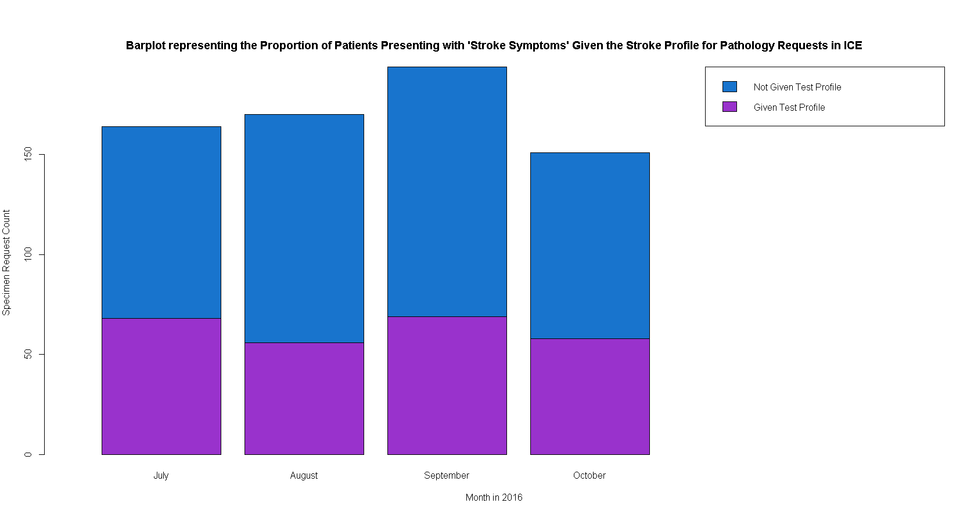
The graph below shows the percentage requesting levels of pathology tests on ‘Stroke Symptomatic’ patients. As with the ACS bundle the bundle tests are generally the most commonly requested, with UE and FBC being requested on almost all patients.
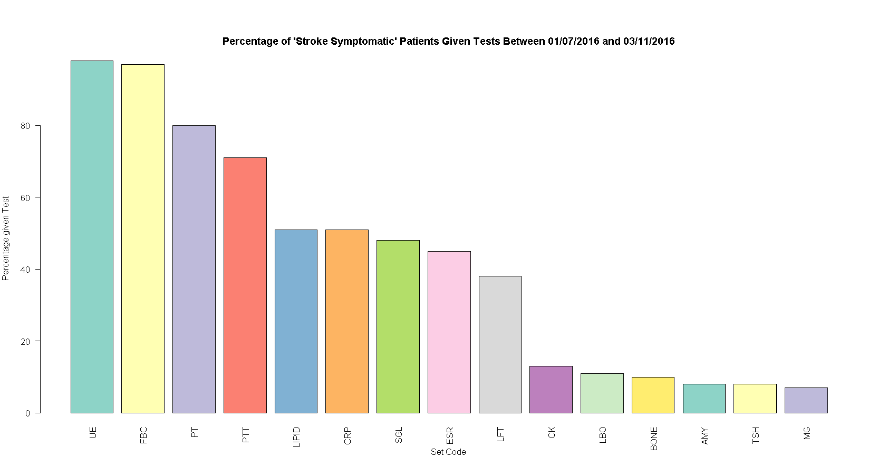
First Fit
This profile suggests UE, FBC, CRP, LBO, SGL and GGT should be tested on all patients displaying signs of a first fit. This bundle has been requested 52 times over the last month; however we have identified 342 patients displaying signs of a first fit.
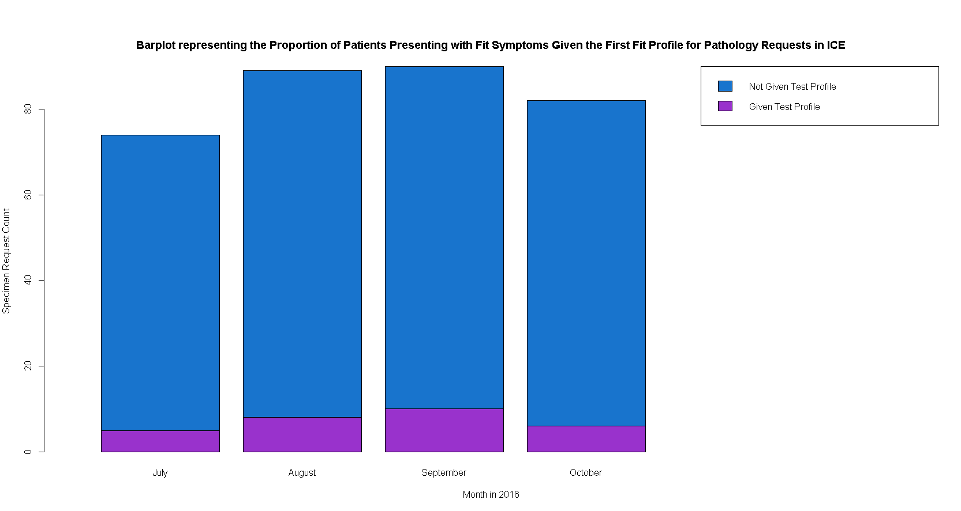
Of the group of 52 patients given the first fit profile only 32 were presenting with symptoms as defined above. 5 of the 20 non symptomatic had no entries in the relevant fields and the other 15 are patients presenting with other symptoms likely given the same sets out of coincidence, giving a bundle tested percentage of 9.4%.
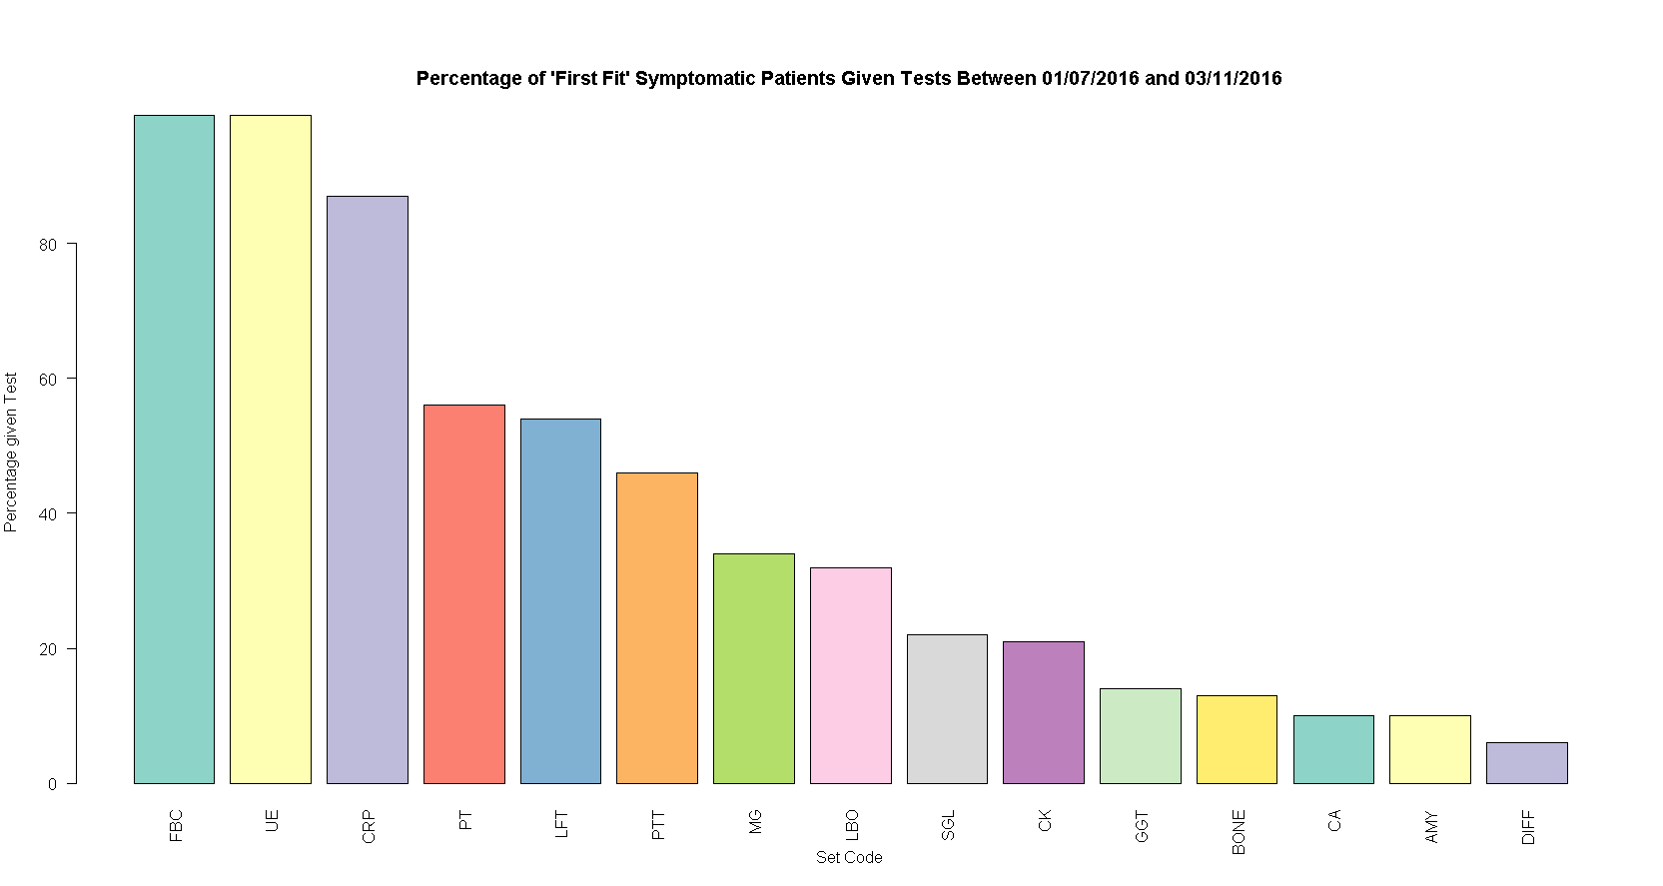
The graph above shows us that most of the “First Fit” patients were given FBC, UE and CRP tests in line with the requesting profile however LBO, SGL and GGT were requested significantly less often.
This might just be because FBC, UE and CRP are very commonly requested for lots of diagnosis and the definition of “first fit” presentation that we have used is inaccurate.
Feedback Response
We’re not interested in data for AMU, PAU, AEC, SAU
I have altered several of the graphs to instead look at the tests being charged to A+E by using consultant code directorate. This does mean that it will include tests requested on patients across the 3 hospital sites, but will only look at tests that will actually be charged to A+E
Can we get ICE to auto populate to A+E instead of OP
This is not a problem with ICE but actually with i-care. If you open ICE directly through its intranet link it should auto-populate to your location.
Is there some way to get ICE to flag up when requests are being repeated?
Yes. ICE already contains some functionality to allow this and some rules are in place already, for TSH thyroid stimulating hormone a repeat within 240 hours should flag an ICE alert. Many of these rules have not been input into the system as they were wiped by a reset several years ago and pathology IT has as of yet been unable to get any clinical confirmation of desired minimum retesting intervals.

Changes to the Dashboard
As mentioned above in the feedback several graphs have had the data selection they pull on changed to better represent A+E requesting by filtering by consultants code. This has the possibility of including some non A+E requests as some consultants work multiple divisions, however these requests will still be charged to A+E as I am using the same method used to define internal recharge levels.
Added total costs figures for Add-on graph and created a bubble chart to display the relative costs by test code.
Added a total cost figure for repeats graph.
Created new ICE graph to represent the % of tests being charged to A+E which are ICE requested instead of looking at admission locations.
Future plans
Develop some minimum retesting intervals to enter on ICE with some consultancy from clinical teams.
We think that this paper on minimum retesting intervals from the royal college of pathologists would be a good place to start generating these.
https://www.google.co.uk/url?sa=t&rct=j&q=&esrc=s&source=web&cd=2&cad=rja&uact=8&ved=0ahUKEwjbsuHuwvDOAhUMBsAKHc3-BmgQFggkMAE&url=https%3A%2F%2Fwww.rcpath.org%2Fasset%2F7A6DA597-181F-4482-B08303CE3907020D%2F&usg=AFQjCNHZKJlZ2rA2Z8ggUlyuyhksP4hZvQ&sig2=oenuo50T7OSU_yspZ9266Q
This may not represent huge financial savings for A+E but the benefits of implementing these intervals would be felt for all ICE users and could create significant efficiency savings across the hospital.
Bundle Investigations – Preliminary bundle investigations have not been added to the dashboard, but could be if there is user interest.
Bugs
The timeflow graph displaying sample time in transport, in lab or waiting to be viewed is inaccurate from 25th September onwards. The ICE server that I need to get the date viewed from has got the wrong memory installed and so can only access a reduced portion of it. Because of this non-essential operations such as my query have been deprioritised. The situation is being investigated but I don’t expect to be able to get a reliable data feed for this anytime soon.
Contact Details
This report was created by Pip Croxford as part of an MSc in Health Informatics for the University of Manchester. She will happily answer any questions and would be grateful for any feedback.
Email: pip.croxford@heartofengland.nhs.uk
Ext: 52956

